**Docker Documentation**

**Docker Architecture:**

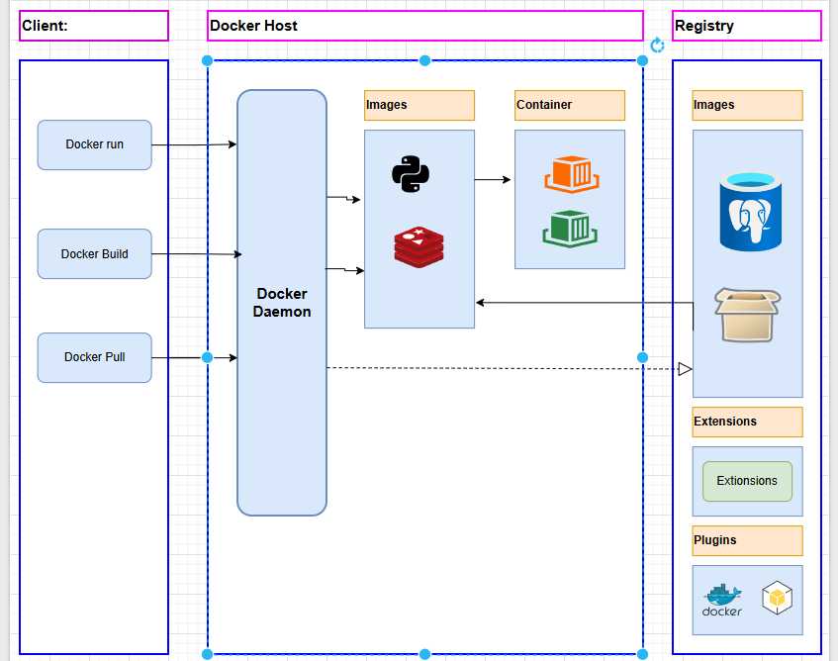

**Client:** In docker client is used to tell docker what to do like : " make a container", " start the app ", and it use “docker run”, “docker build”, “docker pull”

**Docker Host:** It’s the machine (computer or a server) that actually runs Docker and creates containers.

**Registry:** A Docker Registry is like a storage where all applications images are stored. These images are blueprints for running apps inside containers.

**Docker Daemon:** The Docker Daemon is the brain behind Docker. It’s a background service that runs on your computer or server and does all the heavy lifting to manage containers.

You don’t see it working directly—but every time you run a Docker command, the daemon is the one making it happen.

**Docker Image:** A **Docker image** is like the **blueprint** of an application. It contains app code, dependencies, configurations, etc

**Docker Containers :** A Docker container is like a small, lightweight box that holds everything your app needs to run—code, libraries, settings, and more